Ice Cream Manager [ICM]

Use Case Specification Document

Use Case-09

Voting

Version No. v0.2

Project Document Revision History

|  |  |  |  |
| --- | --- | --- | --- |
| Version | Date | Revision Author | Description of Revision |
| 0.1 | 2016-2-26 | Fan Zhang | Initial content generation. |
| 0.2 | 2016-3-6 | Fan Zhang | Made multiple changes and corrections |
|  |  |  |  |

Table of Contents

1.0 Introduction 4

2.0 Use Case Information 4

2.1 Actors 4

2.2 Use Case Interaction 5

3.0 Trigger 5

4.0 Pre-condition(s) 5

4.1 Add Poll 5

4.2 View Poll………………………………………………………………………………………………………………………………………………………………………..5

5.0 Post-condition(s) 5

5.1 Add Poll 5

5.2 View Poll 5

6.0 Use Case Activity Diagram 6

7.0 Main/Basic Flow(s) of Events 8

7.1 Add Poll 8

7.2 View Poll 8

8.0 Alternate/Exception Flow of Events 8

8.1 View Poll 8

9.0 Assumptions/Business Rules including Non-Functional Requirements 8

10.0 Use Case Specification Review and Signoff 9

# Introduction

The purpose of voting is to allow user add new poll to the System as well as analysis the information from the poll after collect all completed customers’ survey delivered by the drivers This use case will cover two distinct but closely related functionalities: add poll and view poll. Manager also will make adjustments to other use cases base on the charts and graphs draw by the database system manager.

# 2.0 Use Case Information

## 2.1 Actors

|  |  |  |
| --- | --- | --- |
| Actor Name | Role | Description |
| manager | Main | The employee who monitors and runs the software in company |
|  |  |  |
|  |  |  |
|  |  |  |
|  |  |  |

## 2.2 Use Case Interaction

This use case has no predecessors, but it has a few successor.

* Predecessor
* Successor
  + UC-01 Modify inventory
  + UC-03 Modify route
  + UC-05 Modify item

# 3.0 Trigger

|  |  |
| --- | --- |
| **Functionality** | **Trigger** |
| Add Poll | No specific trigger, do the poll periodically, 3 months once |
| View Poll | Once the poll has completed and data has been collected into files |

# 4.0 Pre-condition(s)

While this use case is not dependent upon any other use case, some of the functionalities within this use case are dependent upon another. To access the following functionalities, the following conditions must be met:

## 4.1 Add Poll

Add Poll: The survey has to be ready to deliver to costumer.

## 4.2 View Poll

View Poll: All the valid surveys have been collected and transfer the information to data in files.

# 5.0 Post-condition(s)

The Voting use case will cover two functionalities, these two functionalities will perform adjacently.

Their post-conditions are also highly related.

## 5.1 Add Poll

Add Poll: All the information from survey is ready to transfer to data in the files.

## 5.2 View Poll

View Poll: None.

# 6.0 Use Case Activity Diagram

* 6.1 Add Poll

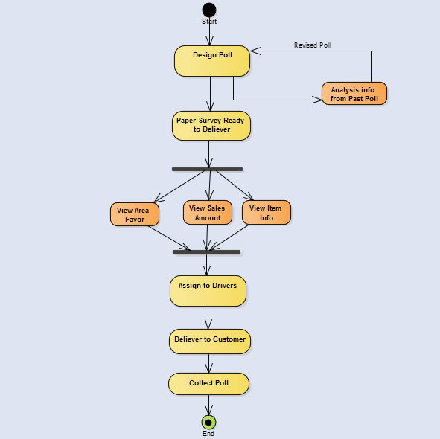

* 6.2 View Poll
* 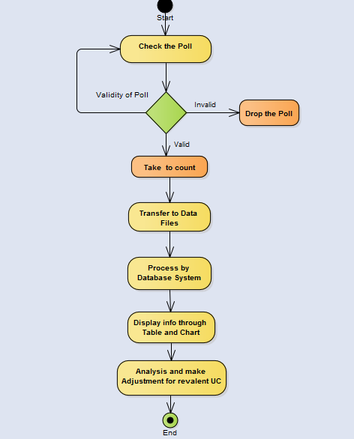

# 7.0 Main/Basic Flow(s) of Events

## 7.1 Add Poll

In this following flow, manager design poll and deliver different version and amount of poll to driver according to area favor and sales amount.

1. Design the Poll
2. Analysis the information from past poll
3. Print out the revised version survey
4. Assign to drivers with different version and amounts of poll according to area favor and sales amount.
5. Drivers deliver the poll to customer while selling the ice cream.
6. Driver collect all the poll.
7. Driver deliver poll back to company’s employee at end of the day.

## 7.2 View Poll

1. After collect all the poll, check the validity of each poll.
2. Drop the invalid poll and put valid poll to count pool.
3. Transfer all the valid poll information to data files in system.
4. System generates all the information and data by different type.
5. All the data will be process by Database system manager.
6. Display the information from poll by chart and graphs.
7. Manager view the graphs and analysis for making adjustment.

# 8.0 Alternate/Exception Flow of Events

## 8.1 View Poll

1. After collect all the poll, check the validity of each poll.
2. Drop the invalid poll and put valid poll to count pool.
3. Transfer all the valid poll information to data files in system.
4. If there any incomplete poll or invalid poll processed by the database system.
5. Replace the invalid information by NULL value in the system.
6. Fill in the blank part which customer didn’t answer by “ Cannot answer”
7. There will be an option “Cannot Answer” in the conclusion graphs and count all the unanswered questions.

# 9.0 Assumptions/Business Rules including Non-Functional Requirements

None.

# 10.0 Use Case Specification Review and Signoff

Review and Signoff of the Use Case Specification

|  |  |  |  |
| --- | --- | --- | --- |
| Name | Project Team Role | Signature | Date |
| Camille Williams | Project Manager |  |  |
| Marc King | Team Lead |  |  |
|  |  |  |  |